**User Experience Phase 3 Group Report**

**Group 14**

**1. How you carried out inspection - based evaluation of the prototype (15%)**

Inspection based evaluation is beneficial as it helped us to uncover usability flaws in our smart home app design. We wanted to design our smart home app to provide support for users with cognitive impairments, thus we decided to carry out an accessibility walkthrough. It is like a cognitive walkthrough, but it considers users with disabilities. For example, limited eyesight, blindness, hearing loss, or cognitive issues. To conduct an accessibility walkthrough, we had to adopt a persona, choose an objective, and follow the instructions to complete the task. We asked ourselves the following questions: Will the user be able to figure out what to do at each step? Is the user capable of performing the tasks? Will the user know that they have done the steps correctly and are advancing toward their objective?

If we were to carry the inspection-based evaluation again then we would conduct a heuristic evaluation. In this method a specialist evaluates an application against a set of principles. This provides a framework for identifying difficulties that a user is likely to experience. Thus, a heuristic evaluation aids in detecting usability issues.

Each group member recruited at least one or two individuals to carry out user testing. We recruited 8 participants in total. We carried out the testing, live in the usability labs, where we made notes of the testers’ experience. The participants that we recruited were our colleagues. The drawback with collecting data from colleagues is that they are familiar with technology and were able to complete each task efficiently. This will affect the total time it takes to complete each task, because someone who is familiar with technology will be able to complete the tasks much faster. If we were to carry out the user testing again then we would like to collect user testing data from people other than our colleagues, to achieve better outcomes.

**2. Summary of findings from the inspection-based evaluation (15%)**

We carried out an accessibility walkthrough for the inspection-based evaluation of our prototype. It was highly effective as we were able to identify various elements in our smart home app that would prevent users with cognitive impairments from successfully completing the tasks. People suffering from cognitive impairment may not be able to understand textual cues and they require icons as an alternative solution. A few options in our smart home consists of just text, if this were an ongoing project then we would remove the text and place corresponding icons in its place. During the accessibility walkthrough we also identified some icons that had a color combination which would make it difficult for people who suffer from colorblindness to see. For example, the prototype had an icon with a red and green color combination. Again, if this were an ongoing project, we would change the color of that icon to make it more color-blind friendly. We also took into consideration users with vision impairments. The size and shape of visual elements (texts and icons) in our prototype may prevent users with vision impairments from completing the task. For example, we found a few icons and text on the prototype were small. So, to combat this in the future, we would increase the size of the texts and icons to make it easier for users with visual impairments to easily view and complete the tasks. Finally, our prototype is currently visual based and does not include any other feature to indicate what the user is interacting with. For example, it will be helpful for users who suffer from complete blindness to have a sound indicator or a haptic feedback feature upon completing a certain step or task in the smart home app. Thus, in future, we would include a feature that would indicate to users who are completely blind if a certain system in the smart home app has been engaged, indicated through sound or vibration.

**3. Your method for user-•-based evaluation (participants, materials, procedure, analysis) (15%)**

The method that we chose for the user-based evaluation is a think aloud protocol. This method requires the users to think aloud and say whatever comes to their mind when they are trying to complete the tasks. For example, they can say what they are looking at, their feelings and what they expect to happen when they are completing the tasks in the prototype. The main benefit of a think aloud protocol is that we can adjust the designs in our prototype if the participants misinterpret some design components. It will also help us identify why the participants get certain elements of the prototype incorrect and others right.

The participants that we recruited to conduct user testing were our colleagues. We were able to recruit 8 participants in total. Due to covid restrictions we were unable to approach random individuals. The location the user testing was conducted was in usability labs. To conduct a think aloud usability testing we will do the following:

* Recruit users to conduct testing.
* Give them the tasks to complete.
* While following the think aloud protocol, have each user complete the tasks.
* Record the time stamp for each task.

After the user testing, we will provide them with an SUS questionnaire to measure the usability of the prototype. Finally, we will be reviewing and analyzing the screen recordings and the SUS questionnaire to obtain useful results and based on this we will provide recommendations for changes to our prototype.

One drawback of a think aloud protocol is that people do not spend a lot of time just talking to themselves, so it makes it difficult for the users to talk in detail about their experience for a continuous period. Also, some users try to behave smartly and do not say things until they have fully understood the situation. This prevents them from saying the things that immediately come to their mind. Additionally, it may be difficult for some users to point out flaws that are not immediately obvious, it could prove difficult for users to engage with the product and give valid criticism on a first impression as opposed to if they had more time to familiarize themselves with the product and how it works.

An eye tracker testing method could be an alternate user-based evaluation that we could have conducted. It can provide insights on how different users engage with the prototype. The eye tracking equipment can show exactly where the user is looking. Light is used to create a reflection in the eye of the user. The tracker's cameras collect these reflections, which are utilized to detect eye movement. This information is shown on the user interface, showing exactly where the user is looking. The main benefit of the eye tracker is that it provides information about how users interact with the prototype. For example, we will identify the gaze patterns when the user is engaging with the prototype. This helps to figure out how users scan the page, for how long and in what order.

**4. Your analysis of the evaluation findings (15%)**

In **‘Task 1,’** we had asked the users to adjust the temperature of the different rooms in the prototype by clicking the up and down arrow. The total time it took for all the participants to complete ‘Task 1’ took between 10 to 15 seconds. All the participants were able to easily navigate to the temperature page of the prototype and adjust the temperature. However, one participant had a lot of mis clicks because the arrow buttons were too small, so the user struggled to adjust the temperature of the room.

Everyone was able to complete **‘Task 2,’** without any errors, which was to navigate to the ‘Lights’ page and turn it on or off for the different rooms in the prototype. The total time it took for all the participants to complete ‘Task 2’ took between 9 to 18 seconds. This was simple because the button is clear on the page located in the center of the lower half of the page, it also has familiarity as the button has the same design as one might see on a smart phone settings page, where a user can toggle it on and off.

Everyone was again able to successfully complete **‘Task 3,’** which was to view a list of CCTV videos of different months on the cameras page. The total time it took for all the participants to complete ‘Task 3’ took between 14 to 20 seconds. For this task, the instructions contained hints on which page to navigate, to find the list of videos for the different months. If we were to do this task again, we would not give any hints and let the user find the videos on their own.

The total time it took to complete **‘Task 4,’** was between 22 to 30 seconds. The reason it took the most time to complete was because everyone struggled to complete it. For example, the users had to connect other devices to the smart home app. However, we had set the pop-up button to the side of the option, and everyone kept pressing the center. So, it took a few clicks for them to eventually find the pop-up option and connect the device to the app. Also, a few users complained that the text on the pop-up option was too small, and they had to lean forward to see clearly what was on the pop-up option.

All users had some confusion with **‘Task 5,’** which was to edit and save your profile. The total time it took to complete this task was between 11 to 25 seconds. The aim of the task was to identify if users were able to locate exactly where the edit profile option was and just view and save it. However, in the task instructions we asked them to “Edit and save your profile.” The users took this instruction to mean that they could actually edit the profile and were confused when they were not able to do so, instead being able to only press ‘save’ and ‘edit’. Hence, it took the users more time to complete this task than it was supposed to.

Everyone was able to successfully complete **‘Task 6,’** which was to view notifications on the prototype. It took a total of 6 to 10 seconds to complete this task. As everyone was able to easily navigate to where the notification option was and view it.

Everyone was able to successfully complete **‘Task 7,’**, which was to create an account and log in to the app. It took a total of 10 to 15 seconds to complete this task.

After the users finished testing the prototype, we provided them with an SUS questionnaire to measure the user satisfaction and usability of the prototype. The results are as follows.

In ‘figure 1’, the majority or 45.5% of the users who tested the prototype, ‘Agreed’ that they would like to use this app frequently. Again, in ‘figure 2,’ the majority or 45.5% of the users ‘Disagreed’ that this app was unnecessarily complex. In ‘figure 3,’ the majority, or 45.5%, of the users also ‘Strongly disagreed’ that they would not need any assistance when using this app. In ‘figure 4,’ 72.2% of the users agreed that the different features of this app were well integrated. In ‘figure 5,’ the majority or 45.5% of the users ‘Disagreed’ that the app has much too much inconsistency. In ‘figure 6,’ the majority or 45.5% of the users ‘Strongly agreed’ that most individuals would quickly learn to utilize the app. In ‘figure 7,’ 90.9% of the users ‘Disagreed’ that this app was inconvenient to use. In ‘figure 8,’ 63.6% of the users ‘Agreed’ that they were confident in using this app. Finally, in ‘figure 9,’ 54.5% of the users ‘Disagreed’ that they would not require much learning to start using the app.

**(The graphs and results of SUS questionnaire can be found in the index)**

**5. Detailed description of specified alterations to the prototype after the evaluation exercises (15%)**

Through the user-based evaluation we were able to identify several issues with the design and functionalities of our prototype. For example, because of small arrow buttons on the temperature page, users found it annoying and difficult to correctly adjust the temperature of the rooms. Evidently, to solve this issue, we would need to increase the size of the arrow buttons to prevent any mis-clicks. One of the tasks contained hints for which page the user had to navigate to, to complete a particular task. Providing hints to users will not give accurate results, hence next time we will not provide any hints and will let the users figure it out themselves. All the users struggled with one of the tasks where they had to connect a device to the app. The users kept pressing on the center of the option and were confused when nothing happened. That was because we had placed the button for the pop-up option on the side of the screen. A simple fix would be to enlarge the button, so that the pop-up option would appear even if the users pressed on the center on the option. Through the think aloud protocol a user said that the text on the prototype was “too small, I can't see”, they had to lean forward to read the text and complete the task. One solution for this is if we increase the size of the text to improve usability of the prototype. Users were also confused regarding one of the tasks that instructed them to “Edit and save their profile.” The aim of that task was to identify if users were able to locate exactly where the edit profile option was and just view and save it. The users took this too literally and were confused and annoyed when they were not able to edit the profile. Thus, next time we will ensure that instructions are written clearly to prevent any confusion.

There were some similarities and differences that we identified from the predicted findings (for inspection) and user-based evaluation. For example, from the inspection-based evaluation we had predicted that some users will find it difficult to read certain texts in the prototype because it was too small and during the user-based evaluation one user complained that they could not see the text. From the inspection-based evaluation we had predicted that because some of the icons in the prototype had a color combination like red and green, it would prevent users who suffer from color blindness from seeing the icons. However, none of the users that we recruited suffered from color blindness and thus they were able to see all the options without any problems.

**6. Discussion on method use (15%)**

For the inspection-based evaluation we conducted an accessibility walkthrough. This method was highly effective as we were able to identify various elements in our prototype that would cause issues for users with cognitive impairments. However, we could have refined this method by carrying out a hybrid approach: heuristic analysis plus cognitive walkthrough. In this method the user is given a set of tasks to complete and at the same time an expert will be reviewing the prototype against a set of principles to identify any issues the user may encounter. This method is effective since we are conducting two inspection-based methods at the same time, thus saving time, and obtaining much better results.

There were a few circumstances that altered our work during this phase. For example, due to covid restrictions we were unable to approach random individuals to conduct user testing. We had to recruit our colleagues. The drawback of recruiting colleagues for user testing is that they are already familiar with technology and thus will complete the task much faster, thus affecting the results. Also due to time constraints we were unable to recruit more than 8 participants for the user testing. Perhaps using more participants and participants from a wider demographic might yield more reliable results, as we would have more than 8 results from a variety of different people.

In an ideal situation it would improve our work if we had access to eye tracking technology and a greater number of participants. For example, we could have measured the user's eye movement to identify what element of the prototype they look at first. How do they scan the pages? what elements they ignore. This technique will allow us to view in real time what the participant sees and identify any design or usability issues right away. We get the added benefit of having several different methods of evaluation and a larger group of more diverse people is certain to produce fairer, more reliable results.

**7. Transcripts and forms (10%)**

**User 1**

**Task 1** (14 sec)

“Going to increase and decrease the room temperature, so I click on the down arrow it decreases and if I click on the up arrow it increases.”

**Task 2** (18 sec)

“My next task is to turn the lights on and off, so I click on this light bulb icon it should…., if I click on this, it should turn off and on.”

**Task 3** (20 sec)

“Check if you can see a list of video recordings for the months of December and February on the camera's page. So, I click on the camera icon, uhm a list of camera recordings for December and February? Ah yes, I do!”

**Task 4** (30 sec)

“On the settings page, connect a device to the smart home app, link devices? There are different devices, you need to be more specific about which device!

**Task 5** (25 sec)

“Check if you can edit and save your profile. (He tried to edit the profile by clicking on the name option) Ah yes, I can”

**Task 6** (7 sec)

“View notification on the home page, so home, notification, yes, I can see it!”

**Task 7** (11 sec)

“Create an account and log in to the app. Create account! and sign up! yes!”

[User 1 Screen Recording 2022-03-08 at 12.28.50.mov](https://livemdxac-my.sharepoint.com/:v:/r/personal/ac1953_live_mdx_ac_uk/Documents/UX%20Design/User%20testing%20videos/User%201%20Screen%20Recording%202022-03-08%20at%2012.28.50.mov?csf=1&web=1&e=crdBYf)

**User 2**

**Task 1** (12 sec)

“Task 1! Increase and decrease the room temperature, so room temperature, increase and decrease, yes works!”

**Task 2** (10 sec)

“So, Task 2, turn the lights on and off, so lights, on and off button, yup works fine!”

**Task 3** (19 sec)

“Task 3, check if you can see a list of videos for the month of December and February on the camera page. Uhm camera page, December video recordings and February video recordings, yes, it is all there!”

**Task 4** (27 sec)

“Task 4, on the settings page connect a device to the smart home app. Uhm link a device? (Clicked on the middle but the button is not the right) Connect to, it is too small to look at, I guess connect, yes looks connected.”

**Task 5** (11 sec)

“Task 5, check if you can edit and save your profile. Uhm edit profile and save!”

**Task 6** (10 sec)

“Task 6, view notifications on the home page, so home page, notifications, yup it's there!”

**Task 7** (15 sec)

“Task 7, create an account and log in to the app. So, create an account, and sign up with email, yes it works fine”

[User 2 Screen Recording 2022-03-15 at 23.03.32.mov](https://livemdxac-my.sharepoint.com/:v:/r/personal/ac1953_live_mdx_ac_uk/Documents/UX%20Design/User%20testing%20videos/User%202%20Screen%20Recording%202022-03-15%20at%2023.03.32.mov?csf=1&web=1&e=X1jut5)

**User 3**

Task 1 - Increase and decrease the room temperature (15 seconds)

I am able to increase and decrease the temperature of any room I want. The page looks good and easy to use. The only downside with this page is that the increase and decrease buttons are too small. (The user mis clicked the buttons several times)

Task 2 - Turn the lights on and off (10 seconds)

I can switch the light on or off in any room I want. I love the idea of having the colors going grey when switching the light off. This page can be improved if I am able to change the colors of the light as well as the brightness.

Task 3 - Check if you see a list of video recordings for the months of December and February on the 'Camera' page (20 seconds)

I can see the list of video recordings for the months of December and February on the ‘Camera’ page.

Task 4 - On the settings page, connect a device to the smart home app (25 seconds)

Yes! I can connect a device to a smart home app. There is nothing that needs to be changed here.

Task 5 - Check if you can edit and save your profile (20 seconds)

I can edit and save my profile, but I wish I were able to edit the profile picture.

Task 6 - View notifications on home page (10 seconds)

I can view the notifications on the ‘Home’ page’ and the design looks good.

Task 7 - Create account and log in to the app (15 seconds)

I was able to create an account and log in but unable to enter my details as it says on the page.

**User 4**

Task 1 - Increase and decrease the room temperature (10 seconds)

Yep, it works.

Task 2 - Turn the lights on and off (9 seconds)

Yep, it is working.

Task 3 - Check if you see a list of video recordings for the months of December and February on the 'Camera' page (14 seconds)

Yes, it does work

Task 4 - On the settings page, connect a device to the smart home app (25 seconds)

Settings. Connect. Yep, it is working.

Task 5 - Check if you can edit and save your profile (11 seconds)

I cannot edit but I can save it.

Task 6 - View notifications on home page (7 seconds)

The task does work.

Task 7 - Create account and log in to the app (10 seconds)

Yep, it does work.

[User 4 screenrecording.mp4](https://livemdxac-my.sharepoint.com/:v:/r/personal/ac1953_live_mdx_ac_uk/Documents/UX%20Design/User%20testing%20videos/User%204%20screenrecording.mp4?csf=1&web=1&e=zQ4JrM)

**User 5**

Task 1 (12seconds): Increase and decrease the room temperature

“No problem Increase decrease.”

Task 2 (10 seconds): Turn the lights on and off

“Turn light on and off”

Task 3 (14 seconds): Check if you see a list of video recordings for the month of December and February on the 'Camera' page.

“December, February. yes, I can see recordings for both”

Task 4 (33 seconds): On the settings page, connect a device to the smart home app

“Connect device to the smart home app? the only available devices are work computer and work laptop, it is connected.”

Task 5 (22 seconds): Check if you can edit and save your profile.

” I can go on edit profile, but I cannot edit the fields. I can save though.”

Task 6 (7 seconds): View notifications on home page

“Yep”

Task 7(15 seconds): Create account and log in to the app.

“It doesn’t let me add details to create account” (then clicks on create account and click on sign in”

[User 5 2022-03-08_160902000_iOS.mp4](https://livemdxac-my.sharepoint.com/:v:/r/personal/ac1953_live_mdx_ac_uk/Documents/UX%20Design/User%20testing%20videos/User%205%202022-03-08_160902000_iOS.mp4?csf=1&web=1&e=FPG33m)

**User 6**

Task 1 (10 seconds): Increase and decrease the room temperature

“Ok, yep.”

Task 2 (9 seconds): Turn the lights on and off

“Done”

Task 3 (15 seconds): Check if you see a list of video recordings for the month of December and February on the 'Camera' page.

“December yes, I can see and February yes, I can see February”

Task 4 (20 seconds): On the settings page, connect a device to the smart home app

“You want me to repeat that again? Yes, On the settings page, connect a device to the smart home app yes, I connected to a device.”

Task 5 (11 seconds): Check if you can edit and save your profile

“Yep"

Task 6:(7 seconds): View notifications on home page

“Yes”

Task 7(10 seconds: Create account and log in to the app.

“Yes, I signed in”

[User 6 2022-03-15_154318000_iOS.mp4](https://livemdxac-my.sharepoint.com/:v:/r/personal/ac1953_live_mdx_ac_uk/Documents/UX%20Design/User%20testing%20videos/User%206%202022-03-15_154318000_iOS.mp4?csf=1&web=1&e=GPiwIS)

**User 7**

**Task 1** (24 sec)

“Increase and decrease the room temperatures”

“It's only letting me change it up and down a few times.”

**Task 2** (30 sec)

“Turn the lights on and off”

“Yup. So, clicking on this button turns it off and on? Ok go it”

**Task 3** (22 sec)

“Check if you see a list of video recordings for the month of December and February in the 'Camera' page”

“Ok. I have done that, and it shows me a different set of recordings or cameras for that month. It only lets me change between December and February though is that what it is supposed to do? Ah ok”

**Task 4** (17 sec)

“On the settings page, connect a device to the smart home app”

“Ok so I click here? And which one do I choose? Ok I think I have done it right?”

**Task 5** (20 sec)

“Check if you can edit and save your profile”

“Hmm ok. Yes, I can enter the profile and save It I guess”

**Task 6** (6 sec)

“View notifications on page?”

“Yeah. Ok so it is only showing a popup is that fine?”

**Task 7** (13 sec)

“Create an account and login to the app”

“So, I click on sign up? Or should I try login? Ok I have done that now should I click this instead? Got it”

[user_testing.mp4](https://livemdxac-my.sharepoint.com/:v:/r/personal/ma3048_live_mdx_ac_uk/Documents/user_testing.mp4?csf=1&web=1&e=d2foIh)

**User 8**

**Task 1** (10 sec)

Now please can you go to the temperature page and increase and decrease the temperature: “yes. I can increase and decrease the temperature”

**Task 2** (10 sec)

Please can you go to the lights page and turn them on and off: “yes. I can turn the lights off and on”

**Task 3** (15 sec)

Now go to the camera page and check if there are any recordings in the months of December and February: “there are recordings in the months of December and in February”

**Task 4** (15 sec)

Now go to the settings page and link a device to the app: “yes. I can connect to my work computer”

**Task 5** (6 sec)

Please can you edit your profile and then save it: “yes I can”

**Task 6** (8 sec)

Now go to the homepage and check if there are any notifications: “yes. There is one notification”

**Task 7** (10 sec)

Can you create an account: “yes.” And can you sign in: “of course”

[user 8 screen recording.mp4](https://livemdxac-my.sharepoint.com/:v:/g/personal/ac1953_live_mdx_ac_uk/Edd5MeEGnPtDs0wbMxCUrJsB4kfWsK8V_9Fc6knP7AWchQ?e=bBmKtE)

**Graphs and Results from SUS (System Usability Scale) questionnaire**

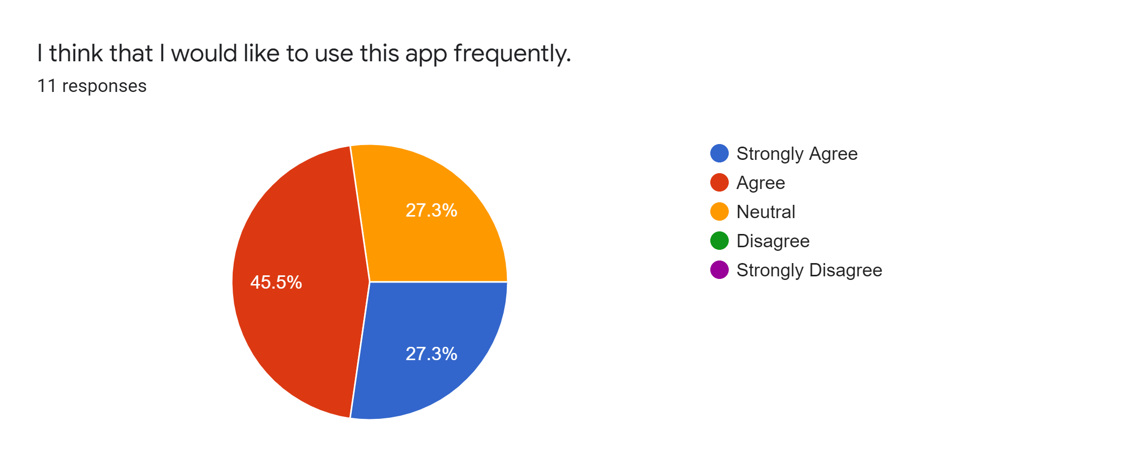

(Figure 1. I think that I would like to use this app frequently)

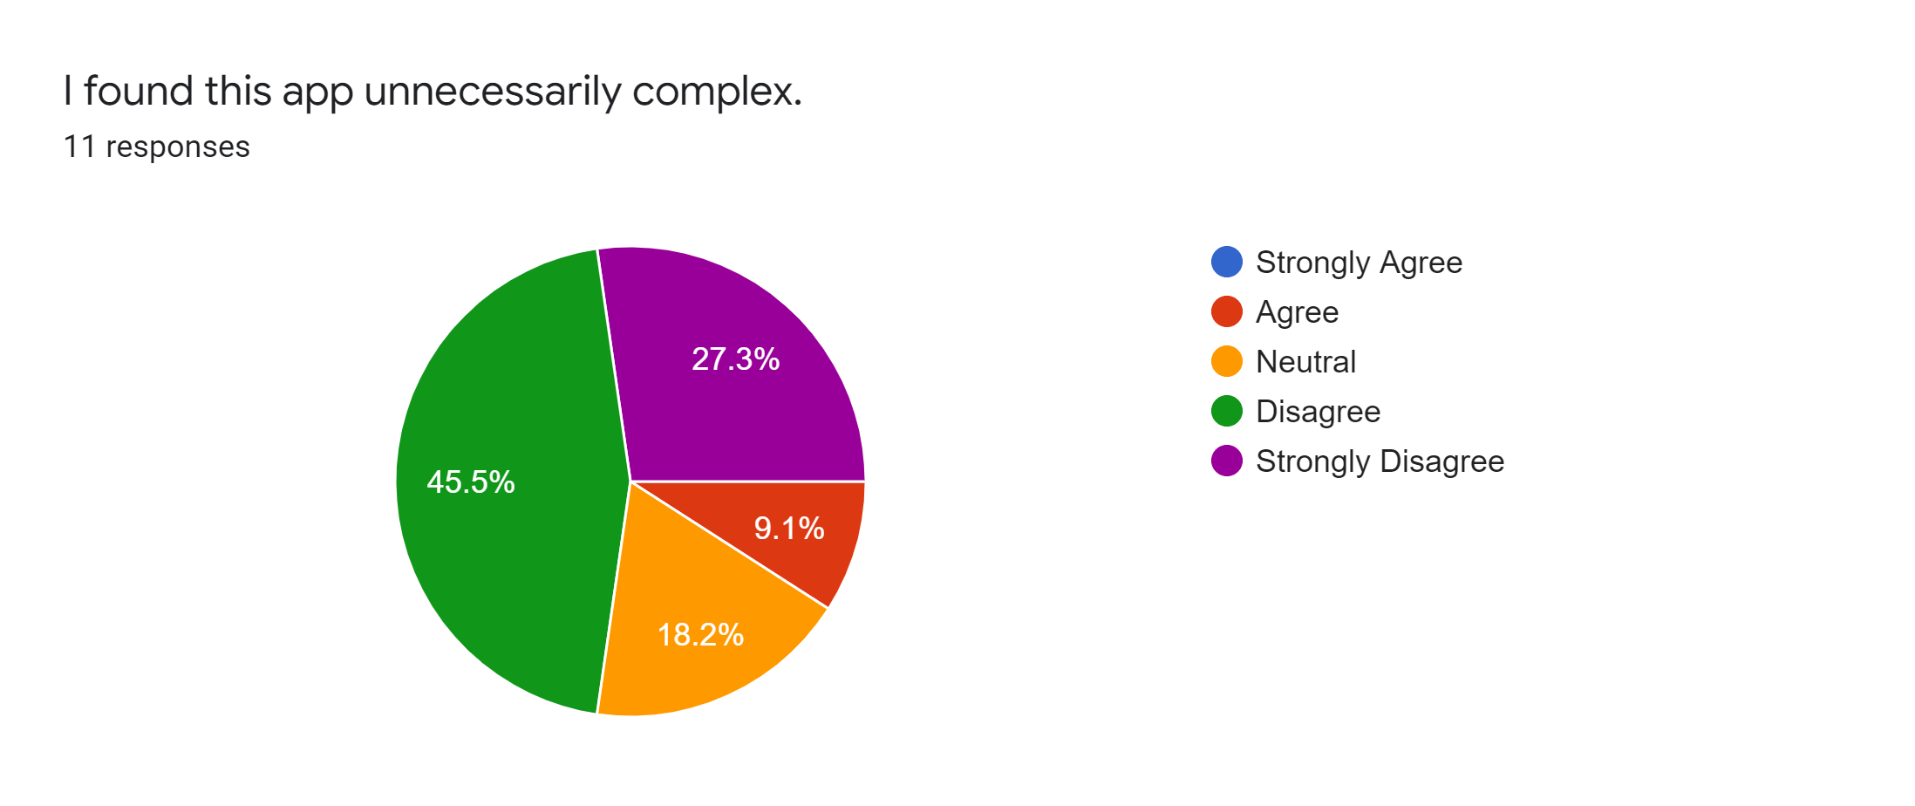

(Figure 2. I found this app unnecessarily complex)

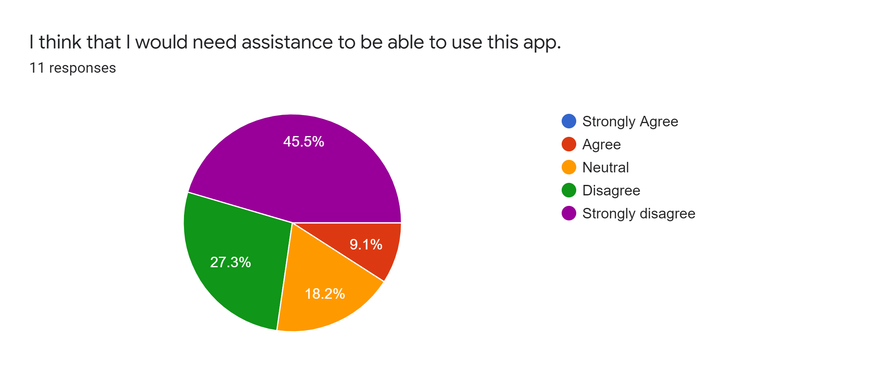

(Figure 3. I think that I would need assistance to be able to use this app)

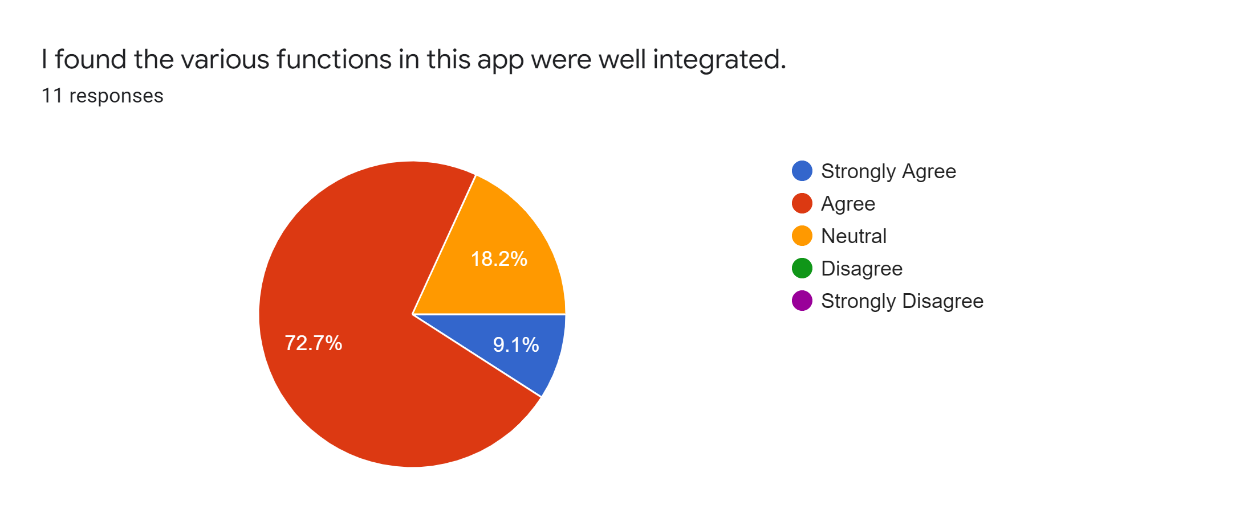

(Figure 4. I found the various functions in this app were well integrated)

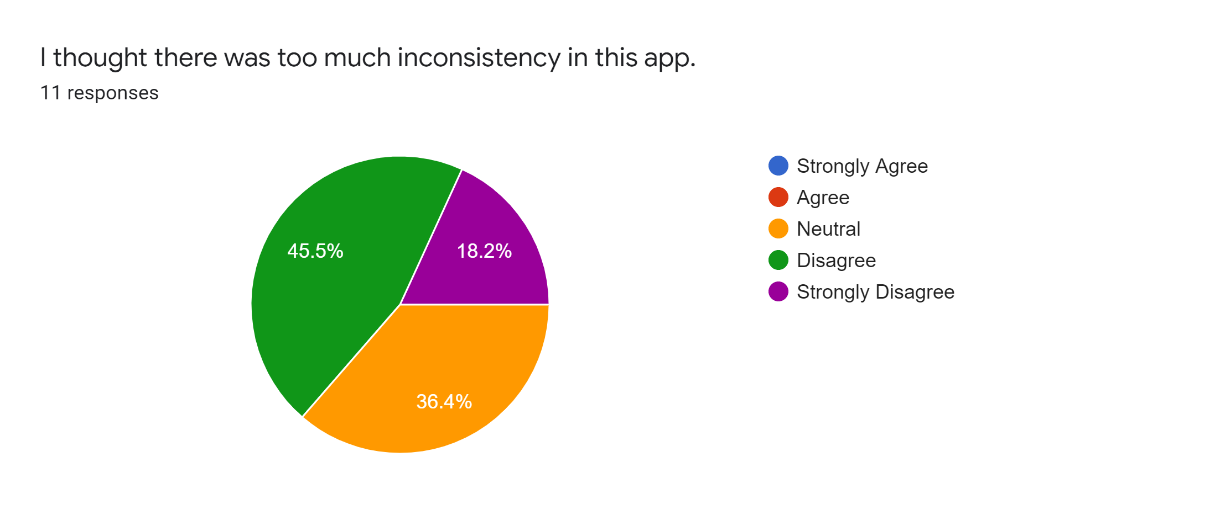

(Figure 5. I thought there was too much inconsistency in this app)

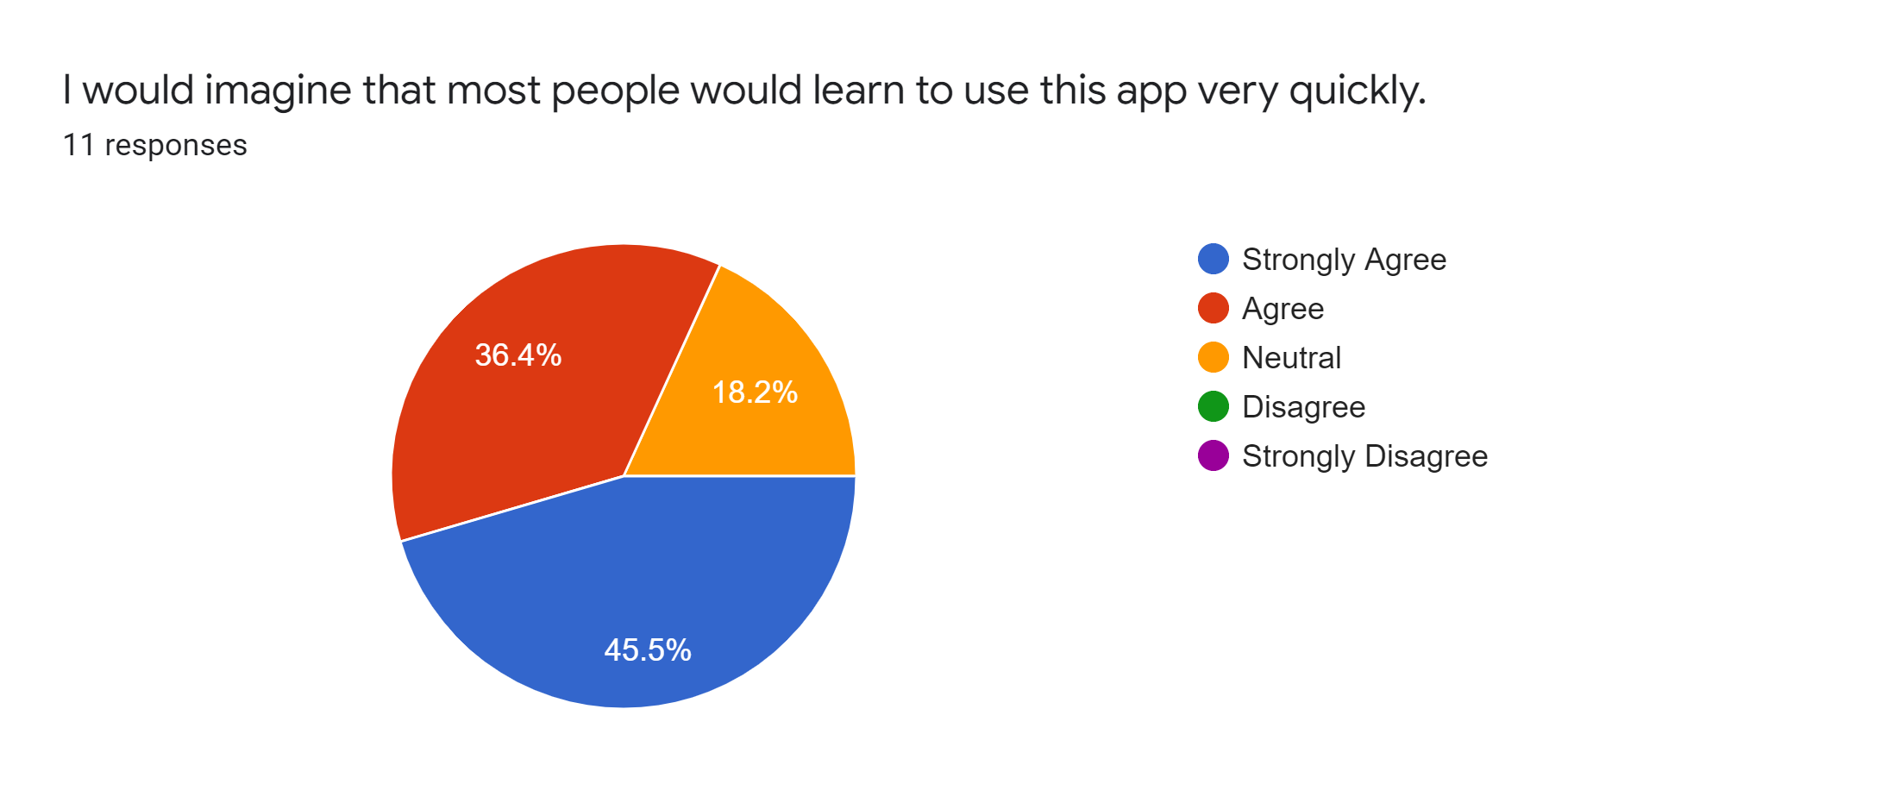

(Figure 6. I would imagine that most people would learn to use this app very quickly)

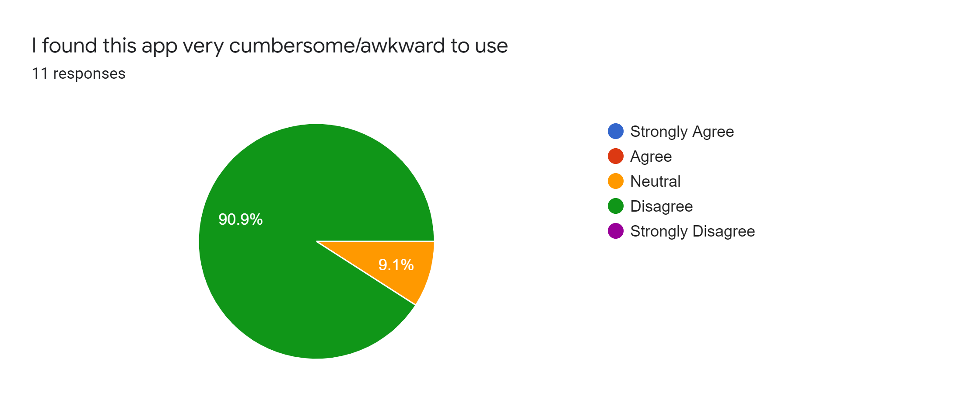

(Figure 7. I found this app very cumbersome/awkward to use)

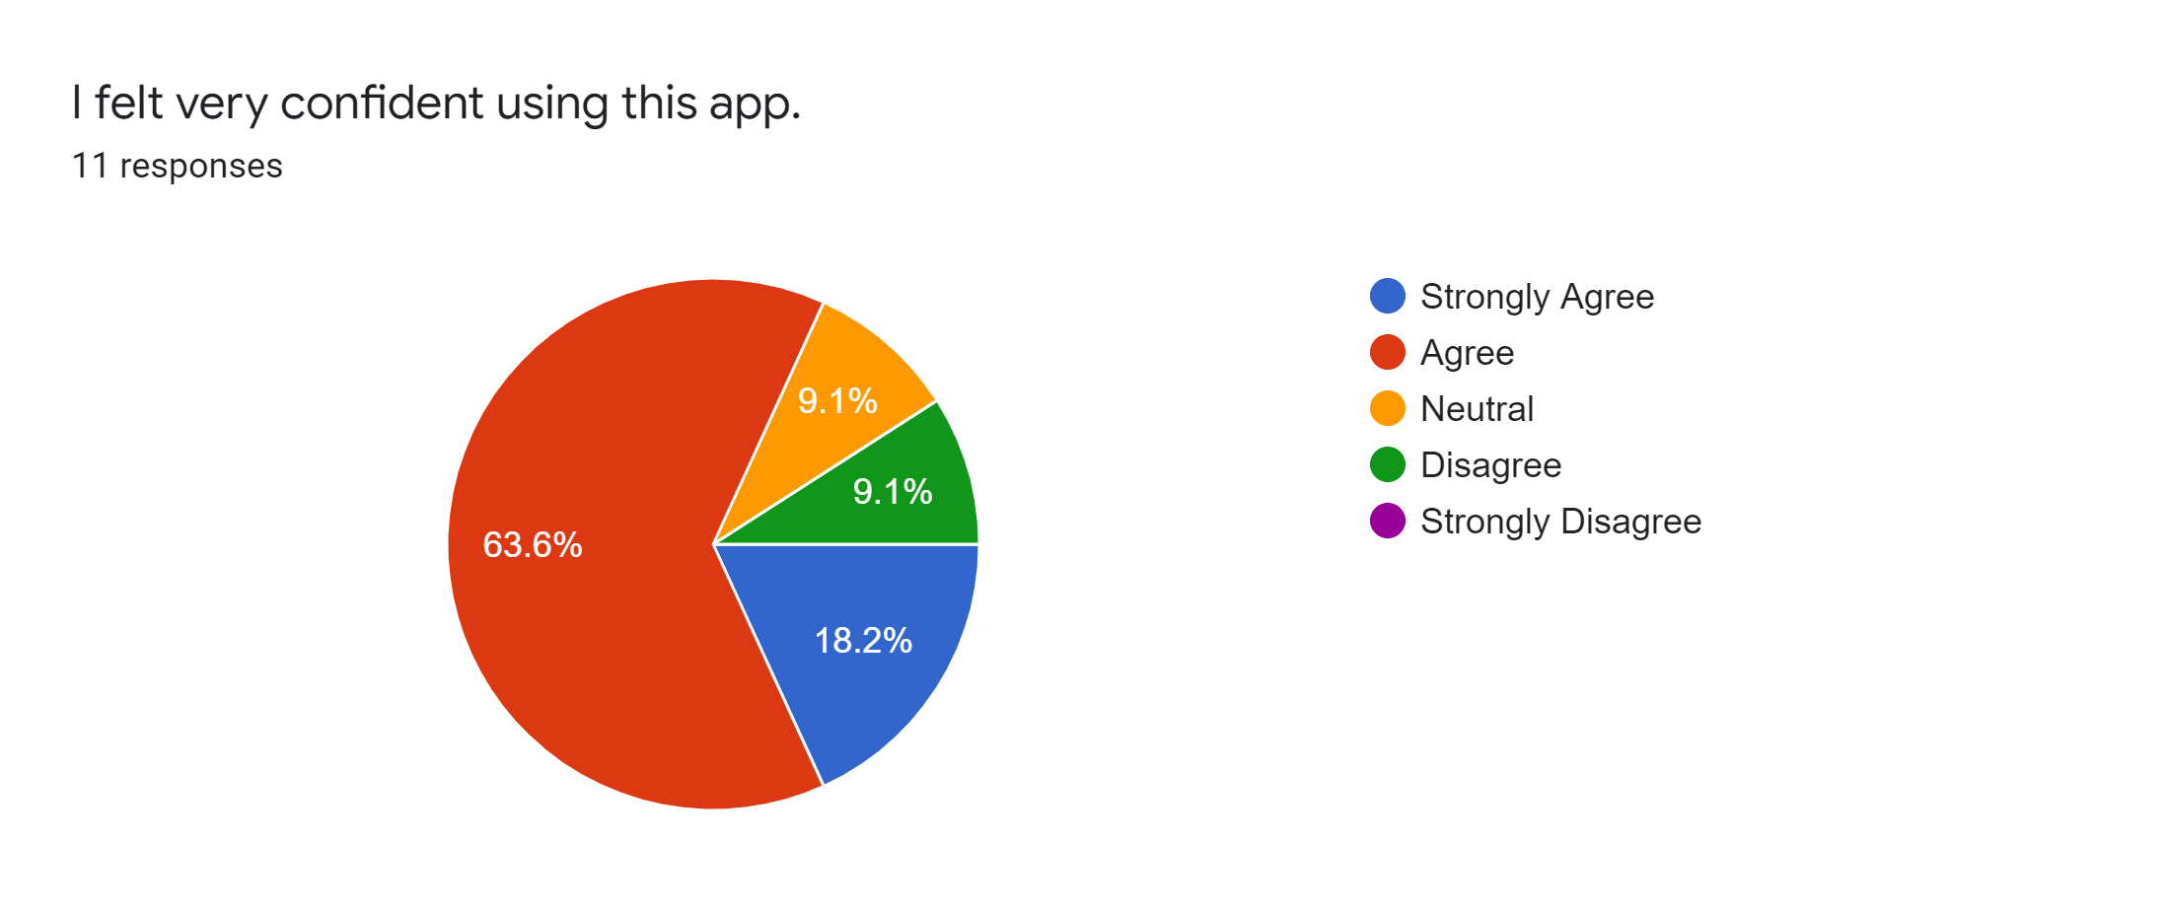

(Figure 8. I felt very confident using this app)

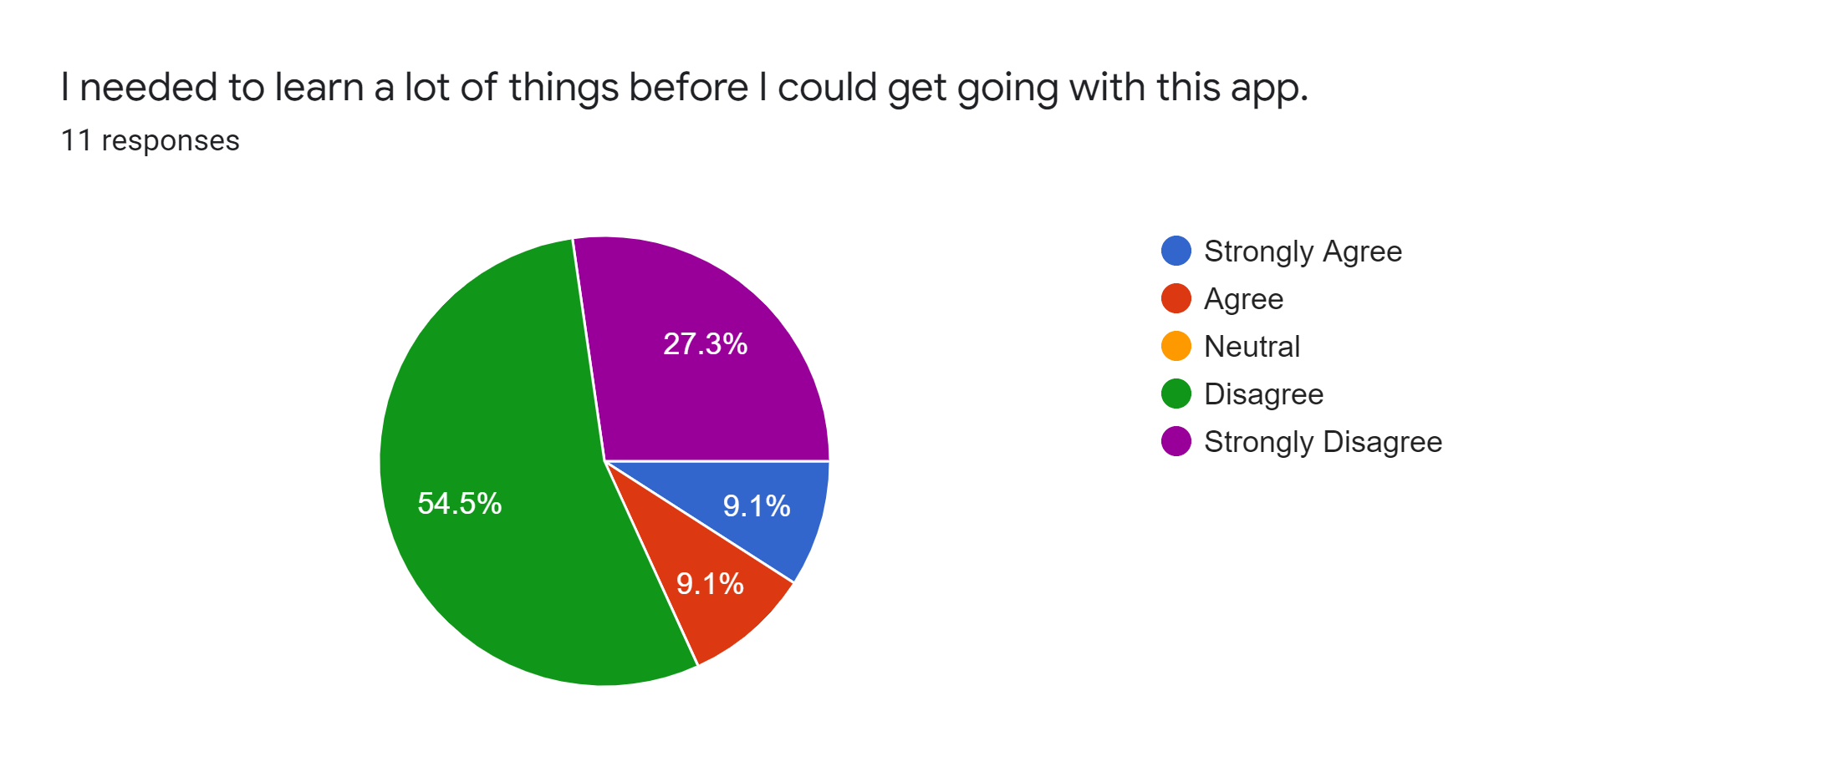

(Figure 9. I needed to learn a lot of things before I could get going with this app)